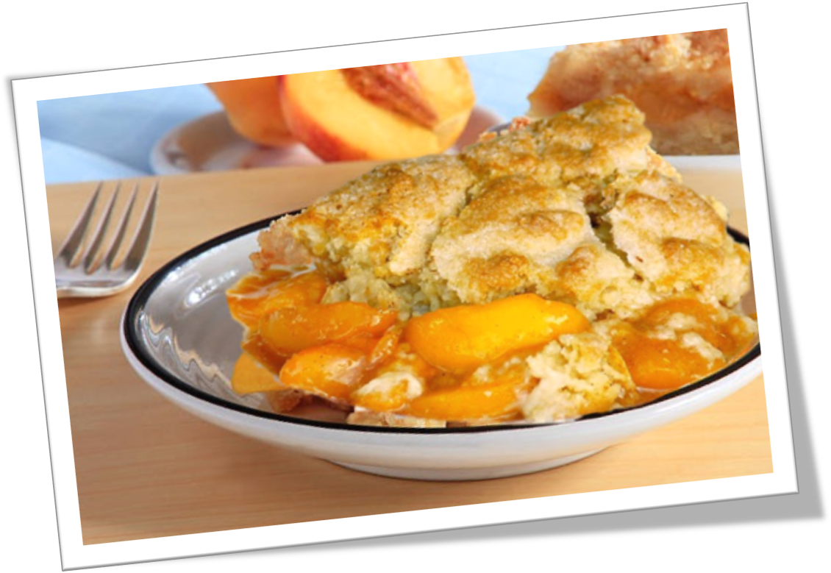
July 13th-24th
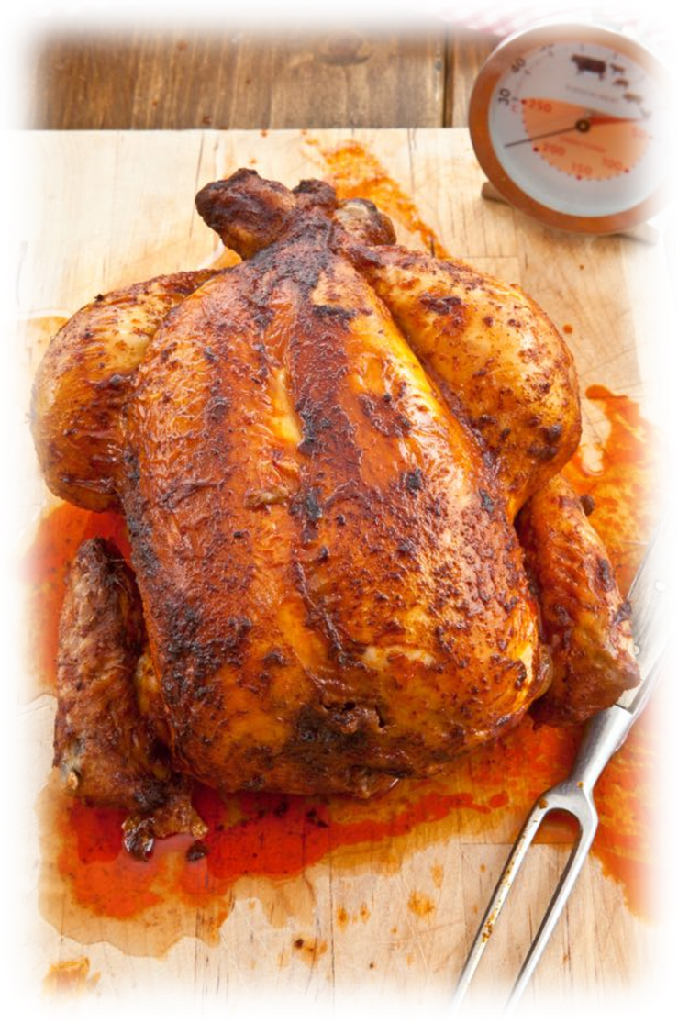
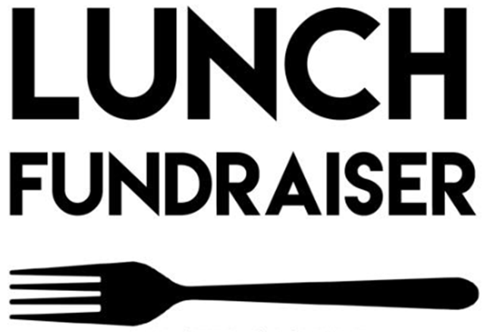
ONLY $7.75!
**add $1 for dessert. **
**add $2.50 for side salad. **
Plates can be delivered.

Delivery fee over 10 miles from Dyer, TN +($2.50)
($20 minimum for delivery)

Plates will include a meat, bread, 2 two sides and drink.

**Side salad can substitute meat, if desired. **
Proceeds will go to support the non-profit organization
Good Samaritan Providers, LLC.


Standard plates include 1 meat, 2 sides, 1 bread and 1 (12 oz) beverage for $7.75

Monday | Tuesday | Wednesday | Thursday | Friday
Side Salad +($2.50) | Side Salad  +(1.00) | Side Salad  +(1.00) | Side Salad  +(1.00) | Side Salad  +(1.00)
Smothered Pork Chop | Salisbury Steak | BBQ Chicken | (4) Wings | Chicken & Dressing
Mashed Potatoes | Cabbage | Baked Beans | Carrots and Celery | Cabbage
Mac&Cheese | Yams | Potato Salad | Cole Slaw | Yams
Cornbread | Cornbread | Roll | Roll | Roll
Peach Cobbler  +(1.00) | Banana Pudding  +(1.00) | Sock-it-to-me Cake +(1.00) | Banana Pudding  +(1.00) | Cherry Cobbler  +(1.00)

Delivery fee over 10 miles from Dyer, TN +($2.50)

(0.20 per additional mile not to exceed 40 miles from base location)

